 | METROLOGY AND MEASUREMENT SYSTEMS  Index 330930, ISSN 0860-8229  www.metrology.wat.edu.pl | 

GUIDELINES FOR PREPARATION OF PAPERS TO THE JOURNAL METROLOGY AND MEASUREMENT SYSTEMS
Hans-Dieter Schmidt¹⁾, Anna Nowak²⁾, Jan Kowalski²⁾
1) Technical University of Munich, Metrology and Optoelectronics Department, Weinstraβe 24, D-08345 Reinsberg, Germany (hdschmidt@iog.com.de)
2) Warsaw University of Technology, Faculty of Electronics and Information Technology, Institute of Radioelectronics, Nowowiejska 15/19, 00-665 Warsaw, Poland ( j.kowalski@abc.pw.edu.pl, +48 22 432 7721, a.nowak@abc.pw.edu.pl).
Abstract
This document provides guidelines for preparing manuscripts to the journal Metrology and Measurement Systems. Please use this document as a template file. The manuscript title is the first thing that catches readers attention. Thus, it has to be possibly short and informative. The title should be written using uppercase letters and font size of 12 pt. An abstract is the next thing that the readers check after spotting your article. Make sure it contains key points of your manuscript, is comprehensive, self-contained and concise. Avoid abbreviations, footnotes, references, mathematical equations or tabular material in this part. The abstract should be written as one paragraph, have about 8-10 lines and be printed using the font size of 10 pt. The abstract is followed by 3–6 keywords. It links your manuscript with other related articles. Using appropriate keywords it is easier for other researchers to find your work in their field of interest. Take your time to find the keywords that fit best to the content of your manuscript. Please go through this document to find other important hints about manuscript preparation.
Keywords: Metrology and Measurement Systems (M&MS) journal, manuscript preparation, editing, peer review, submission process.

Introduction
Metrology and Measurement Systems (M&MS) is an international journal, peer-reviewed, quarterly-published, launched in 1988. Since 2001 it has appeared in English. Since 2024, the journal has been published exclusively in electronic form on the Electronic Library platform of the Polish Academy of Sciences (PAS): https://journals.pan.pl/dlibra/journal/mms. M&MS operates on a diamond open access model: authors do not pay any publication fees, and articles are made available open access under the terms of the Creative Commons Attribution Non Commercial-No Derivatives License (CC BY-NC-ND 4.0) [1].
The following types of papers are published in M&MS:
- review papers presenting the current stage of the knowledge within the scope of the journal (max. 24 edited pages, approximately 3000 characters each),
- research papers reporting original scientific or technological advancements in the field of metrology (max. 16 pages),
- papers based on extended and updated contributions presented at scientific conferences (max. 16 pages),
- short notes, i.e. book reviews, conference reports, short news (max. 2 pages).
The text of a manuscript should be written in clear and concise English. The camera-ready format (as in this file) – with attached separate files containing illustrations, tables and photographs – is required. A cover letter with clear explanation of scientific novelty of the paper is strongly recommended. Papers based on extended and updated contributions presented at scientific conferences, or strongly related to previous authors’ works, must be accompanied with a cover letter file which should explain in details changes made in the manuscript in comparison with the original conference paper and highlight the novelty in reference to other authors’ works.
We do not charge for overlength pages. However, the research article should be written in a matter-of-fact way, describing particular problem or solution. Short but informative articles, with easy to follow structure, are better received by readers and improves your work impact.
Typically papers published in scientific journals follow a common structure that includes in general Introduction, Method, Results and Discussion sections, often known as the so-called IMRaD format. For authors who are writing their first scientific article we strongly recommend to have a look on some guides, e.g. [2, 3].
In the starting section (usually called “Introduction”) the problem under study should be described and positioned with respect to the state-of-the-art by quoting appropriate references, especially related to the field of metrology. It very rarely happens that the work is completely new and cannot be compared to any existing knowledge. Highlight the novelty of your work, possible application and why this problem is worth to be investigated.
The following sections represent the main part of the paper. They should contain the description of the methods and procedures used, as well as the presentation of the obtained results of study. The inclusion of examples, illustrating the applications of those results, is recommended. If the reader was intrigued by the manuscript abstract, here is the place to give all details needed to understand your idea as well as to present obtained results. This part may also include discussion about advantages and disadvantages of proposed solutions. Be aware that the scientific paper must include some kind of novelty as well as enough details to be repeated by other researchers. These rules do not apply only to the review papers.
In the final section, conclusions from the reported research should be provided, in particular – the efficiency of the proposed solution(s) of the research problem should be assessed and compared with the existing ones (if exist). The applications of results obtained have to be indicated and prospects for future developments outlined. At the end, a list of adequate references must be provided.
These guidelines are structured as follows. In section 2 technical aspects of the manuscript preparation are described, including formatting details and preparation of mathematical equations, figures and tables. Section 3 focuses on proper selecting of references as well as presents some common formatting examples. Section 4 gives some additional information including step-by-step description of the whole publication process, starting from uploading the manuscript to the Internet Editorial System (IES) up to the final publication of the article. This kind of paragraph, containing description of subsequent sections, is often used at the end of paper introduction section but it is not necessary.

Preparation of manuscript – technical aspects
The main text of a manuscript should be written on an A4 page (with margins of 2.5 cm) using Times New Roman style with a font size of 12 pt; the paragraphs should start with the indentation of 5 mm, and titles should be written in bold. The text can be divided into sections (numbered 1, 2, ...), first-order subsections (numbered 1.1., 1.2., ..., written in italics), and – if needed – second-order subsections (numbered 1.1.1., 1.1.2., ..., written same as first-order subsections). The only acceptable manuscript formats are .doc or .docx).
The title page should include: the manuscript title (written using uppercase letters only), authors' names (using bold) and their affiliations with company e-mail addresses (using italics). The corresponding author should be identified by the symbol of an envelope and phone number. If you want to emphasis some part of your work please use bold – do not underline and leave italics for other use, e.g. for company or program names, etc. Do not abuse bold – this must be used only for the most important things.
The authors of submitted papers who are not English native speakers are encouraged to use a language service checking the correctness not only with respect to grammar, but also in the way of presentation of research results accepted by renowned publishers e.g. presented on the website of the European Association of Science Editors (https://ease.org.uk/).

Figures and tables
Figures (illustrations, photographs) and tables, provided in the camera-ready form suitable for reproduction (which may include reduction), should be additionally submitted (one per page). While preparing figures we encourage to start with defining expected size and minimum font size that fit to all graphics in the manuscript – using the same style in all of your graphics visually improves your article. Also make good use of the figure area to not leave too much empty space around. Final figure formats must be in one of the following: (vectors) .svg, .eps, .pdf, .ai or .cdr, and (bitmaps) .bmp, .gif, .png or .jpg. Photographs should have minimum resolution of 200 dpi. In case of bitmap figures that present plots the required resolution is 400 dpi. The minimum font size is 7 pt. All fonts that appear in the figure should be embedded or converted to outlines in order to achieve possibly best-quality results.
As far as plots, block diagrams, schematics etc. are concerned, we suggest to use one of vector formats to improve quality and scalability. Figures in vector formats must be saved using RGB colours and with fully white background (0% K). Hidden layers are unacceptable. Minimum line thickness printed in a single colour is 0.25 pt (0.09 mm), and 1 pt (0.36 mm) when using more colours. Typically we suggest 0.2-0.5 mm but in particular cases the range 0.1–1.0 mm will be accepted. Lines in plots should be distinguished not only by using different colours but also using different line types and markers, if needed. An example plot is presented in Fig. 1.
Figures and tables should be separated from the text by one free line before and after. The figure caption should be written using font size of 10 pt and placed below the corresponding figure, while the table caption – above the table. A 6-point interspace between the figure and its caption, as well as between the table and its caption is required. Also 10-point interspace after figure caption is needed. Generally the abbreviation “Fig. 1” should be used, except at the beginning of a sentence where “Figure 1” is recommended. For tables use always full form, e.g. “Table 1”. The text in tables should be written using 10 pt Times New Roman font.

Fig. 1. Example plot.

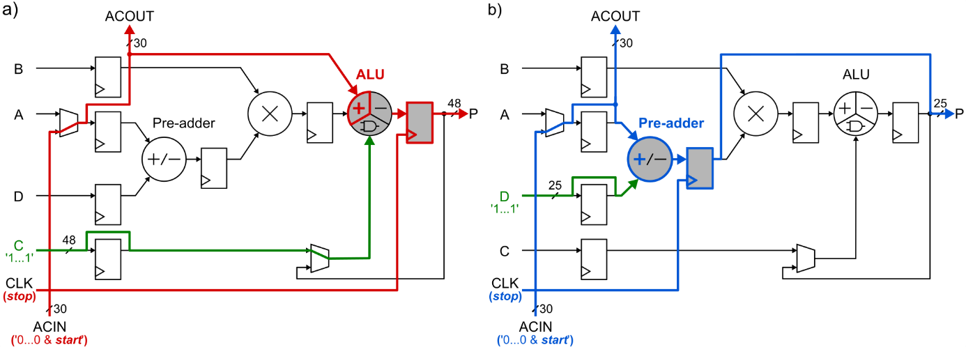
Fig. 2. A simplified DSP48E1 slice configuration as a TDC with the use of ALU (a) or a pre-adder (b) [4].

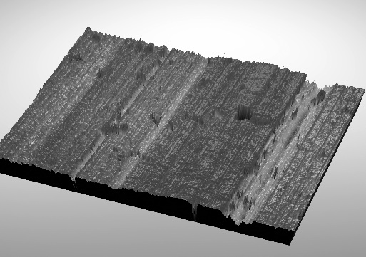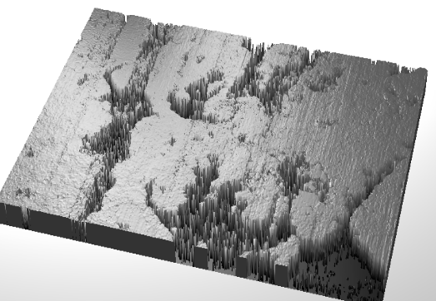
Fig. 3. Brake drum (left) and lining (right) after 250 000 kilometres of covered distance.

Table 1. Results of numerical experiments for stationary and nonstationary filters.
Filter type | [ms] | [ms] | [g] | [g]
Stationary, 4th order, | 333 | 46 | –0.015 | 0.06
Nonstationary, 2nd order, , | 269 | 22 | 0.0 | 0.095

Four different exemplary figures and a table are shown here: Fig. 1 – for illustration of plots, Fig. 2 – for illustration of block diagrams, Fig. 3 – for showing photographs, Table 1 – a table with mathematical symbols. We recommend to locate figures on the top or bottom of page but always close to adequate reference in text.

Equations and units
All equations must be numbered consecutively throughout the text. Each equation should be preceded and followed by a 6-point spacing. Punctuate equations when they are part of a sentence. Equation numbers should be enclosed in parentheses and flushed right as below:
(1)
Equations should be prepared with the use of MathType or Microsoft Equation editors. The type size in the equation is the same as for the text. To make your equations more compact, you may use the appropriate mathematical symbols or expressions. The symbols used in an equation have to be defined before that equation or immediately after it. Use italics for variables (e.g. i, x, n), physical quantity symbols (e.g. voltage U, temperature T), letter pointers and general function symbols. Do not use italics for constants, indexes, minimum, maximum and trigonometric functions, mathematical operators, differentials, etc. To refer to the equation use “(1)”, not “Eq. (1)” or “equation (1)”, except at the beginning of a sentence where “Equation (1)” should be used. We recommend to use International System of Units SI i.e. metre-kilogram-second system of units. As a decimal separator dot should be used in the entire manuscript (text, figures, tables).

References

Primary field of interest
The paper has to be clearly positioned in the context of relevant literature in the field of measurements and instrumentation. Note that lack of references from the main field of M&MS interest may suggest that the content of manuscript does not exactly correspond to the scope of our journal. It may reduce possibility that a proposed paper will be read by adequate society. In such a case our Editorial Board may suggest to send the manuscript to more appropriate journal. Table 2 gives examples of some relevant and recognizable journals related to widely understood metrology. The use of possibly up-to-date references (preferably from the last 2-5 years) may indicate importance of your work. To search previous issues of the journal M&MS for up-to-date and relevant articles look at the Electronic Library of the PAS: http://journals.pan.pl/mms.
Table 2. Examples of renewable journals from the field of measurements and instrumentation.
Journal | Publisher | ISSN
Metrologia | IOP Publishing | 0026-1394
IEEE Transactions on Instrumentation and Measurement | IEEE | 0018-9456
Measurement | Elsevier | 0263-2241
Measurement Science and Technology | IOP Publishing | 0957-0233
Metrology and Measurement Systems | PAS | 0860-8229
Review of Scientific Instruments | IOP Publishing | 0034-6748
Flow Measurement and Instrumentation | Elsevier | 0955-5986
IET Science, Measurement & Technology | IET | 1751-8822
Journal of Instrumentation | SISSA, IOP Publishing | 1748-0221
Measurement Science Review | Walter de Gruyter | 1335-8871
IEEE Instrumentation and Measurement Magazine | IEEE | 1094-6969
IEEE Sensors Journal | IEEE | 1558-1748
Sensors | MDPI | 1424-8220

References format
References should be inserted in the text in square brackets, e.g. [1]; their list, numbered in citation order, should appear at the end of the manuscript. The format of the references should follow the APA 7th edition formatting style [5], i.e.: for a journal paper – surname(s) and initial(s) of author(s), year in brackets, title of the paper, full journal name, volume, issue (in brackets) and page numbers. Put all author names unless there are more than 20. Otherwise, after the first 19 authors’ names, use an ellipsis in place of the remaining author names. Then, end with the final author's name (do not place an ampersand before it).
The references published in other languages than English should be avoided because of very limited availability for foreign readers. The list of references should conform to the examples for books [6], e-books [3], book chapters [7], journals [8-11], conference proceedings [12], theses [13], datasheets [14], online documents [1, 5] and patents [15].

Other information

Supplementary files
Metrology and Measurement Systems provides possibility to include supplementary files related to the article content, such as e.g. developed databases. If you developed your own database that is used in the article you can share it with other researchers by uploading it, after the article is accepted, to the M&MS journal servers. The content of the database can be then used by other researchers to compare their algorithms using the same input data. For more details about supplementary files please contact the Editorial Board: metrology@wat.edu.pl.

Biographical notes
The biographical statements, at the very end of the article, are not obligatory, however, they are kindly recommended. Each statement should include the author’s full name and brief personal history focused on areas of research and scientific achievements. The biographical statement may not exceed 100 words and should be written using Times New Roman style with a font size of 8 pts. Three examples are shown at the end of this file.

Preprints
We allow processing of manuscripts previously made available as preprints in open repositories. However, information about the release of the paper should be noted in the cover letter. In the case of acceptance decision, appropriate information about publication in M&MS with a link to the final version of the article should be added to the preprint.

Manuscript submission
Manuscript should be submitted via the IES using the link available at http://www.editorialsystem.com/mms – an online submission and peer review system. In order to submit the manuscript via the IES, the authors (first-time users) must create an author account to obtain a user ID and password required to enter the system. The submission of the manuscript in a single file, i.e. “Article File” containing the complete manuscript (with all figures of high quality and tables embedded in the text), is required. All figures have to be uploaded in separate files saved in a one of formats specified in subsection 2.1. The generated PDF file has to be approved. The PDF file has lower quality of the embedded figures to limit its size only. Final article will be published with high quality graphics.
The submission of a manuscript means that its content has not been published previously, it is not under consideration for publication elsewhere, and that – if accepted – it will not be published elsewhere. The authors are obliged to sign the relevant Copyright Form (License to publish) available in the IES. This license also indicates non-commercial use of the article governed by the Creative Commons Attribution Non Commercial-No Derivatives License (CC BY-NC-ND 4.0) [14].
The authors are urged to suggest 4 to 5 reviewers in their application (with names, affiliations and addresses) with whom the Editorial Board could co-operate while processing the paper. Proposed reviewers should be experts deeply involved in issues related to the subject matter of the paper, are intended to come from different universities or research centres and should not have conflicts of interests resulting from competitive, collaborative, or other relationships or connections with any of the authors, companies, or institutions connected to the manuscript.

Manuscript review and production process
Each submitted manuscript is subject to a single-blind peer-review procedure (reviewers know the identity of authors, but authors do not know the identity of reviewers), and the publication decision is based on the reviewers’ comments. If necessary, the authors may be invited to revise their manuscripts. In the case of revisions, we require the authors to include an explanation letter with detailed responses to the reviewers' and editor's comments and to clearly mark in the manuscript the changes made.
We stipulate that before submitting a paper for review, our editors verify the scope of the subject matter and its relevance to the field of Instrumentation and Measurement. An essential criterion for the evaluation of submitted manuscripts is their potential impact on the research field, measured by the number of repeated quotations. Such papers are preferred at the evaluation and publication stages.
On acceptance, manuscripts are subject to editorial amendment to exactly fit the journal style. This version is then published as early access. We provide final linguistic proofreading of the manuscript, but we require manuscripts to be linguistically correct at the time of submission. Authors are obliged to respond to the linguistic editor's comments within the given deadline. The final version of the article, before publication in the Electronic Library of the PAS, must be once more approved by the authors.

How to promote your article
The publication of your article is a great achievement but then it needs to be further promoted to make it more visible to the research community. Responsibility for this task lies with the authors and our Editorial Board. We guarantee free access to the article in the Electronic Library of the PAS (http://journals.pan.pl/mms), including articles in Early Access form (published just after acceptance decision), indexing in popular and renewable databases (e.g. Clarivate Web of Science, Elsevier Scopus, Google Scholar). Furthermore, selected articles are highlighted on the journal website (http://www.metrology.wat.edu.pl/) and are reprinted for promotion at conferences and other similar events. The authors can share the final form of the article on various social networks and research-sharing platforms, such as Twitter, Facebook, LinkedIn, ResearchGate, Academia.edu, SciProfiles, etc. They are also encouraged to update personal and institutional webpages by adding the title and a link of the article. Feel free to share your work with your colleagues using also any other methods that do not conflict with the CC BY-NC-ND 4.0 license [1].

Conclusions
Conclusions section is often used to elaborate on the importance of the work and suggest potential applications or further works. While it may also review the key parts of the paper this cannot be just rephrased abstract.
This paper summarizes key elements to properly prepare manuscript to the journal Metrology and Measurement Systems. Accepted manuscripts are available free of charge in the Electronic Library of the PAS and indexed i.a. in Clarivate Web of Science, Elsevier Scopus and Google Scholar databases. For any other questions please contact us: www.metrology@wat.edu.pl. We look forward to receiving your manuscript soon.

Acknowledgements
Here is a place for optional acknowledgments as in examples below.
The authors would like to thank Prof. Ewa Kowalczyk from Central Office of Measures in Warsaw, Poland, for valuable suggestions on the performed experiment.
This work was supported by the German Society for Knowledge Advancement (grant # 567-000-123), by the Ministry of Science and Higher Education, Poland (grant # N555 011 31/1000), and by National Institute of Scientific Research of French Republic (grant # NISR08-555/024).

Appendices
This section is optional and may include any additional materials that may help to understand the paper, especially proofs of mathematical equations. If there is only one appendix, it requires neither a number nor a name, but is simply labelled Appendix. If there are multiple appendices, they should be identified as A, B, etc. and titled as in an example: Appendix A: The quantization error evaluation. Formulae and equations in appendices should be given separate numbering e.g. (A.1), (A.2), etc.; in a subsequent appendix, (B.1) and so on. Similarly for tables and figures: Table A.1; Fig. A.1, etc. Other format rules for the body of manuscript apply accordingly to Appendices.

References
- Creative Commons. (n.d.). Attribution-NonCommercial-NoDerivatives 4.0 International license (CC BY-NC-ND 4.0). https://creativecommons.org/licenses/by-nc-nd/4.0/legalcode
- Borja, A. (2014, June 24). 11 steps to structuring a science paper editors will take seriously. Elsevier Connect. https://www.elsevier.com/connect/11-steps-to-structuring-a-science-paper-editors-will-take-seriously
- Mack, C. A. (2018). How to Write a Good Scientific Paper. SPIE. https://doi.org/10.1117/3.2317707.sup
- Kwiatkowski, P., (2019). Employing FPGA DSP blocks for time-to-digital conversion. Metrology and Measurement Systems, 26(4), 631-643. https://doi.org/10.24425/mms.2019.130570
- American Psychological Association. (n.d.). Style and Grammar Guidelines – References. https://apastyle.apa.org/style-grammar-guidelines/references/
- Rogalski, A., Kopytko, M., & Martyniuk, P. (2018). Antimonide-based Infrared Detectors: A New Perspective. SPIE. https://doi.org/10.1117/3.2278814
- Szplet, R. (2014). Time-to-digital converters. In Carbone P., Kiaei, S., & Xu, W. (Eds.). Design, Modeling and Testing of Data Converters (pp. 211-246). Springer-Verlag. https://doi.org/10.1007/978-3-642-39655-7_7
- Bielecki, Z., Janucki, J., Kawalec, A., Mikołajczyk, J., Pałka, N., Pasternak, M., & Wojtas, J. (2012). Sensors and systems for the detection of explosive devices – an overview. Metrology and Measurement Systems, 19(1), 3-28. https://doi.org/10.2478/v10178-012-0001-3
- Barman, I., Dingari, N. C., Singh, G.P., Soares, J.S., Dasari, R.R., & Smulko, J. M. (2012). Investigation of noise-induced instabilities in quantitative biological spectroscopy and its implications for noninvasive glucose monitoring. Analytical Chemistry, 84(19), 8149–8156. https://doi.org/10.1021/ac301200n
- Borkowski, J., Kania, D., & Mroczka, J. (2014). Interpolated-DFT-based fast and accurate frequency estimation for the control of power. IEEE Transactions on Industrial Electronics, 61(12), 7026–7034. https://doi.org/10.1109/TIE.2014.2316225
- Aidala, C. A., Arrington, J. R., Ayuso, C., Bowen, B. M., Bowen, M. L., Bowling, K. L., Brown, A. W., Brown, C. N., Byrd, R., Carlisle, R. E., Chang, T., Chang, W.-C., Chen, A., Chen, J.-Y., Christian, D. C., Chu, X., Dannowitz, B. P., Daugherity, M, … Yin, Y. (2019). The SeaQuest spectrometer at Fermilab. Nuclear Instruments and Methods in Physics Research Section A: Accelerators, Spectrometers, Detectors and Associated Equipment, 930, 49-63. https://doi.org/10.1016/j.nima.2019.03.039
- Czaja, Z. (2006). A fault diagnosis method of analog parts of mixed-signal systems controlled by microcontrollers. Proceedings of the IEEE Instrumentation and Measurement Technology Conference, Italy, 1211–1216. https://doi.org/10.1109/IMTC.2006.328453
- Bro, R. (1998). Multi-way Analysis in the Food Industry – Models, Algorithms, and Applications. [Doctoral dissertation, Universiteit van Amsterdam]. http://www.models.kvl.dk/sites/default/files/brothesis_0.pdf
- Xilinx. (2016). 7 Series FPGAs Configurable Logic Block. [User Guide UG474, v1.8]. https://www.xilinx.com/support/documentation/user_guides/ug474_7Series_CLB.pdf
- Kwiatkowski, P. (2017). Układ generacji ciągu impulsów elektrycznych o regulowanych relacjach czasowych (Polish patent No. 233271). Patent Office of the Republic of Poland. https://grab.uprp.pl/sites/Opisy/Miniaturki/Opisy/3730051.pdf


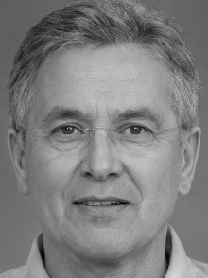
Hans-Dieter Schmidt received the Ph.D. degree from Heidelberg University, Germany, in 1997. He is currently a Full Professor and the Head of the Metrology and Optoelectronics Department in the Technical University of Munich. He has authored or coauthored 2 books, 4 book chapters, over 50 journal and 100 conference publications. He holds 24 issued U.S. patents and was a recipient of the Second Technological Invention Award of German Ministry of Education. His current research interests include femtosecond lasers and optical fiber technology.


Anna Nowak was born in Wroclaw, Poland in 1990. She received the M.Sc. (2017) degree from Warsaw University of Technology (WUT), Poland. From 2017 to 2019, she held engineering positions in few electronic companies where she was involved in developing measurement instrumentation for physic experiments. She is currently pursuing the Ph.D. degree with the Electrical Energy Group, WUT.
Jan Kowalski obtained the B.Sc. and M.Sc. degree in electronics and communications engineering and the Ph.D. in applied science from the Military University of Technology, Warsaw, Poland, in 2007, 2009 and 2015, respectively. He is currently Assistant Professor with the Warsaw University of Technology, Poland.
His research activity focuses on energy-efficient sensing, and sensor networks for the condition monitoring and health diagnosis of large-scale, complex, and dynamical systems.

